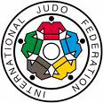
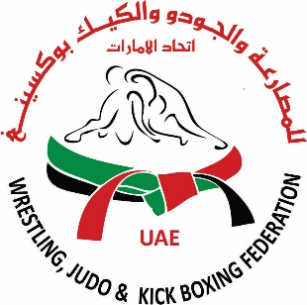
UAE Wrestling & Judo Federation

IJF REFEREEING SEMINAR 2018,
ABU DHABI, UAE

IMPORTANT INFORMATION  Deadline For Registration: December 23, 2017  Governing Body: International Judo Federation  IJF will invite one Referee and one Coach from each National Federation. Accommodation with Full Board Meals and Airport Transfers (from Abu Dhabi International Airport) will be organized and paid for by IJF.  Travel Fees to Abu Dhabi is the responsibility of the delegates. Arrivals in Dubai will incur extra charge for airport transfers.  Additional delegates can attend at their own costs (details below). All delegates/participants must be registered in Judobase by their National Federation. Participants to bring white Judogi for the practical session. Registration to be done to organizer (for hotel and visas to hotel@uaewjjf.com) and to IJF Mr.T.Kawaguchi . ,k.kamohara@judo.or.jp | Organiser Contacts:-  UAE Wrestling & Judo Federation  PO Box 3573  Abu Dhabi, UAE  Tel. +971-55 101-0443  Email: hotel@uaewjjf.com
PROGRAM  Date Time Events  Jan 18th 2018, Thursday Afternoon Arrivals of Delegates  Jan 19th 2018, Friday 10:00 - 18:00 Preparation Meeting Seminar Theoretical / Practical Part 1 + 2 11:30 – 12:00 and 16:00 – 16:30 Coffee Break, 13:30 Lunch  Jan 20th 2018, Saturday 09:30 – 11:00 11:30 – 13:30 Theoretical /Practical Part 3 Seminar Theoretical / Practical Part 4 & Conclusion 11:00 – 11:30 Coffee Break 14:00 pm Lunch  Jan 21st 2018, Sunday Morning Departure of Delegates  The seminar will include an explanation of the IJF Refereeing Rules and will be practical as well as theoretical. Please bring Judogi for the practical sessions.  Please note:- IJF covers only double rooms on a sharing basis for each National Federation. If you need single rooms, the difference will be paid by the participants/National Federation. | Dates  18-21 January 2018  Location  Abu Dhabi, UAE
ACCOMMODATION (IJF COVERS 1 REFEREE AND 1 COACH for each National Federation)
Hotel: Grand Millennium Hotel, Al Wahda, Abu Dhabi, UAE (5 star hotel with shopping mall attached to it)

IJF Covers 1 Referee and 1 Coach for each National Federation in a double room on sharing basis.

If delegates need single room, they need to pay the difference of US 175 per federation for 2 persons in 2 single rooms directly to Organiser.

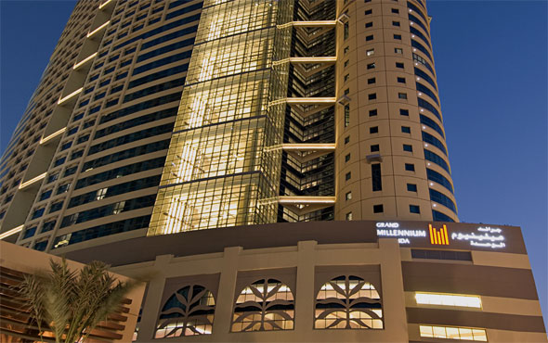

ADDITIONAL DELEGATE COSTS
For any additional delegates, National Federation has to register to both IJF and the organizer. All travel expenses as well as accommodation, airport transfers and meals for these additional delegates also will be the responsibility of the National Federation. These costs to be paid in advance to the National Federation for the bookings to be done.

Double Room (sharing basis): US$ 375 for full board per night
Single Room (per person): US$ 275 for full board per night per person

Airport Transfer: US$ 85 for airport transfers both ways from Abu Dhabi International Airport

Seminar Delegate Costs: 120$ per additional delegates (staying full board in hotel) for the 2 day meeting room

Bank Details for Organiser:

Beneficiary’s Name: UAE WRESTLING & JUDO FEDERATION
Bank Name: Abu Dhabi Commercial Bank (ADCB)
Bank A/C No: AE180030010424519020001
Bank Address: Main Branch, Sh Zayed Street, Abu Dhabi
SWIFT Code: ADCBAEAA

Payment should be made by Bank Transfer and a copy of the Bank Transfer Advise should be sent to the organizer in advance of arrival to get confirmation of room bookings and seminar participation.

